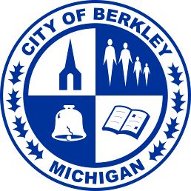
LIBRARY BOARD AGENDA

Wednesday, January 21, 2026 at 7:00 p.m.

at the Berkley Public Library (3155 Coolidge Hwy.)

- Call to order

- Officer selections

- Public comments

- Approval of minutes from November 19, 2025 meeting

- Librarian’s report

- Old business
  - Circulation statistics
  - Library card policy

- New business

- Update from City Council liaison

- Adjourn

Next meeting: Wednesday, February 18, 2026 at 7:00 p.m.

